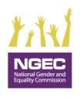
REPORTING TOOL ON GENDER MAINSTREAMING IN THE GOVERNMENT OF KENYA 2023/2024

Public Sector Biannual Gender Mainstreaming Reporting Tool FY 2023/24

Biannual: Tick as appropriate 1 =(July 2023-December 2023) ☐
2= (January 2024-June 2024) ☐
Full Name of the Ministry/ Department/ Agency or County:

………………………………………………………………………….……………………………………………………………………
- Type of Institution (Tick where applicable)
- Ministry/State Department  - State Corporation  - Public University |  | - Tertiary Institution  - Semi-Autonomous Government Agency  - County Government  - Others (specify)__________
B. Indicators
- Were gender mainstreaming activities included in the annual work plan? |  |  |  |  |  |  | Yes [ ]  No [ ]
2. a) What is the total amount of your MDA's 2023/24 annual budget. |  |  |  |  |  |  | Total budget:  KShs…………………..…………….
b) State amount allocated for Gender Mainstreaming and GBV Prevention and Response in the Financial Year 2023/2024. |  |  |  |  |  |  | Budget for Gender mainstreaming and GBV programming:  KShs.………………………………………………………
- Does your MDA or County have a Gender Mainstreaming Policy aligned to the National Policy on Gender and Development, 2019? |  |  |  |  |  |  | Yes [ ]  No [ ]  Attach evidence
4. Did your MDA or County implement the Gender Mainstreaming Policy in (3) above? If yes, indicate the actions below: |  |  |  |  |  |  | Yes [ ]  No [ ]
(i) Implement flexible working hours for staff who are nursing infants |  |  |  |  |  |  | Yes [ ]  No [ ]
(ii) Have a lactation room or crèche facility at the workplace |  |  |  |  |  |  | Yes [ ]  No [ ]
(iii) Apply a Gender lens (gender considerations) such as affirmative action in its programs or projects |  |  |  |  |  |  | Yes [ ]  No [ ]
(iv) Others (specify) ………….……………………………………………………………………………………………………………………………………………………………………………………………………………………………………………………………………………………………………………………………………………………………………………………………………………………………………………………………………………………………………………………………………………… |  |  |  |  |  |  | Attached evidence?  Yes [ ]  No [ ]
Indicators |  | Sex |  |  | Persons With Disabilities |  | Minorities &  Marginalized  Communities |  | Age Category
 |  | F |  | M | F | M | F | M | Below 35 |  | 35 & above | Total
- Total number of staff in MDA or County
- Number of employees in job group “P” and above or its equivalent
- Number of board members or its equivalent
- Number of recruited officers in the reporting period excluding interns and attachés
- Number of officers promoted in the reporting period
- Does your MDA or County have a workplace policy on Gender Based Violence (GBV) in line with the relevant national policies and laws? |  |  |  |  |  |  | Tick as appropriate  Yes [ ]  No [ ]  Attached evidence?  Yes [ ]  No [ ]
6. Did your MDA or County implement the workplace policy on Gender Based Violence in (5) above? |  |  |  |  |  |  | Yes [ ]  No [ ]
If yes in 6 above, indicate the actions and attach evidence  ----------------------------------------------------------------------------------------------------------------------------------------------------------------------------------------------------------------------------------------------------------------------------------------------------------------------------------------------------------------------------------------------------------------------------------------- |  |  |  |  |  |  | Attached evidence?  Yes [ ]  No [ ]
- Please highlight any emerging issues or challenges faced in the process of mainstreaming gender and inclusion in your institution

-----------------------------------------------------------------------------------------------------------------------------------------------------------------------------------------------------------------------------------------------------------------------------------------------------------------------------------------------------------------------------------------------------------------------------------------------------
- Submit to the State Department for Gender and Affirmative Action on Email: pcontracting@gender.go.ke and a copy to the National Gender and Equality Commission: Email: pcontracting@ngeckenya.org

NB: This reporting tool should be signed and stamped by the Authorized Officer; and submitted not later than 5th of the month following the end of the half-year period.

- Name of Authorized Officer:………………………………………………………. Signature:………………………… Date……………………………..

Name of Reporting Officer | Designation |  | Telephone Number |  |  | Email Address |  |  |  | Date

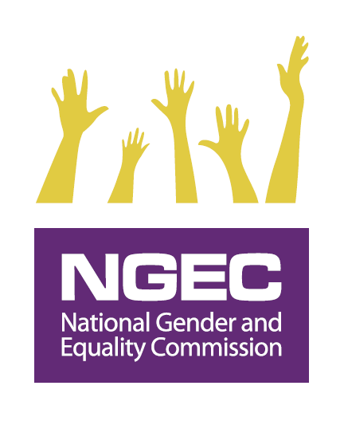

MEASURING PERFORMANCE ON THE GENDER MAINSTREAMING INDICATORS: 2023/2024
Indicators as per Reporting Tool | Key Performance Indicators | Variables | Weight/Score
1. Were gender mainstreaming activities included in the annual work plan? | Institutional work plan with GBV and gender mainstreaming actions/activities included (5%) | Work plan | 5%
2. b) State amount allocated for Gender Mainstreaming and GBV Prevention and Response in the Financial Year 2023/ 2024. | Allocation of a budget for Gender mainstreaming and GBV programming in the financial year in the work plan. (15%) | Budget | 15%
3. Does the MDA or County have a Gender Mainstreaming Policy aligned to the National Policy on Gender and Development, 2019? | Developing/Reviewing/Have in place a gender mainstreaming policy (10%) | Gender Mainstreaming Policy | 10%
4. Did the MDA or County implement the Gender Mainstreaming Policy in (3) above? | Implementation of the Gender  Mainstreaming policy (20%) | Activities derived from the policies | 20%
Disaggregation of data on all employees as guided in the reporting tool checking on the two-thirds gender principle, disability mainstreaming & general inclusivity | - Complete disaggregation of data (5%)  - Compliance with the 2/3 gender rule (2%)  - Compliance with the at least 5 % employment of PWDs (3%) | Disaggregated data by:  - Sex  - Disability  - Minority and Marginalized  - Age | 10%
5. Does your MDA or County have a workplace policy on Gender Based Violence (GBV) in line with the relevant national policies and laws? | Developing/Reviewing/Have in place a workplace policy on Gender Based Violence (10%) | Workplace policy on GBV | 10%
6. Did your MDA or County implement the workplace policy on Gender Based Violence in (6) above? | Implementation of the workplace GBV policy (20%) | Activities derived from the policy | 20%
Submission of Biannual reports using the prescribed format to the State Department for Gender and Affirmative Action with a copy to National Gender and Equality Commission | - Use of prescribed reporting format (5%)  - Submission of biannual reports (5%)  (First half will be by 5th January and second half will be by 5th July) | - Submission of the biannual report using the reporting template as provided and observing timelines | 10%
Total Score |  |  | 100%

As provided in the relevant circulars of the National Treasury
For more information about the policy visit http://psyg.go.ke/wp-content/uploads/2019/12/NATIONAL-POLICY-ON-GENDER-AND-DEVELOPMENT.pdf

